**PRACTICAL 2**

**Commands:**

1 Display Date

2 Update and upgrade all software packages

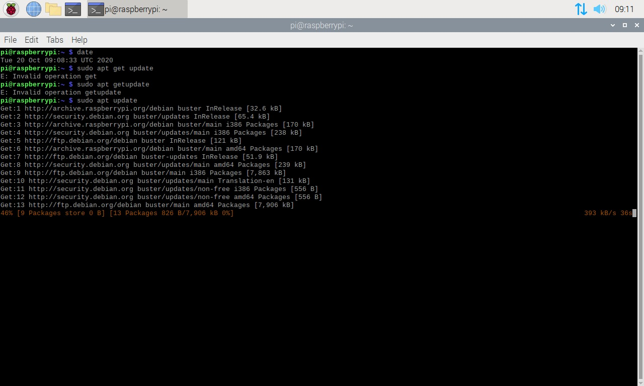

3 Display Calendar

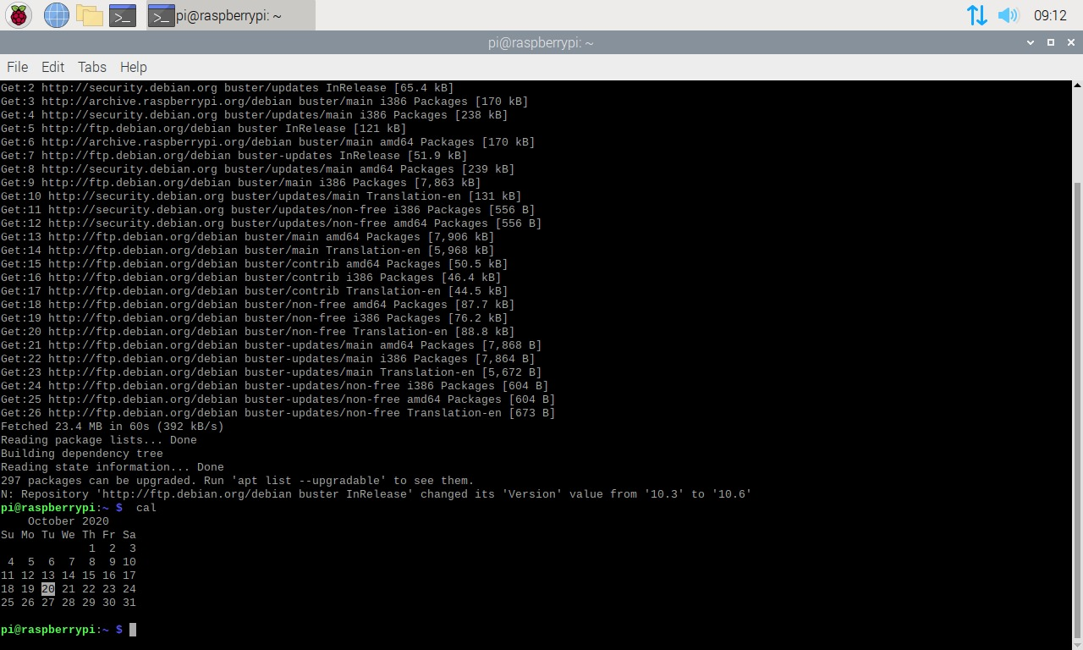

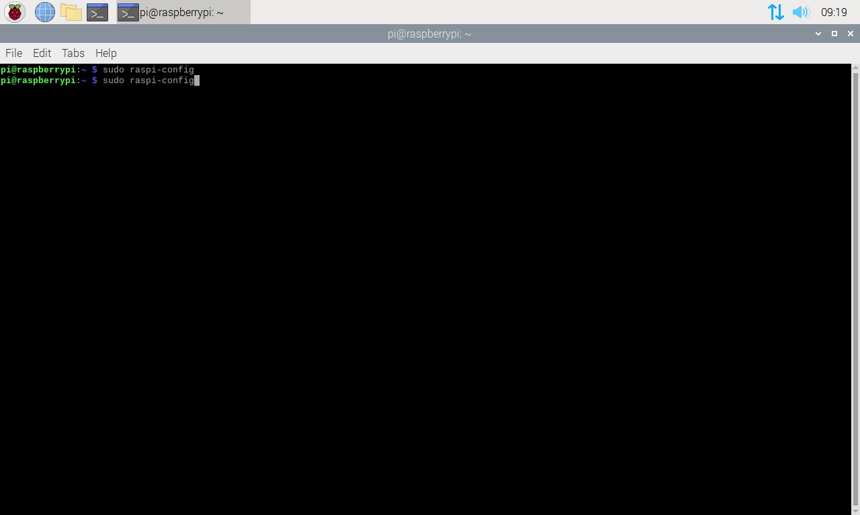4 Open configuration setting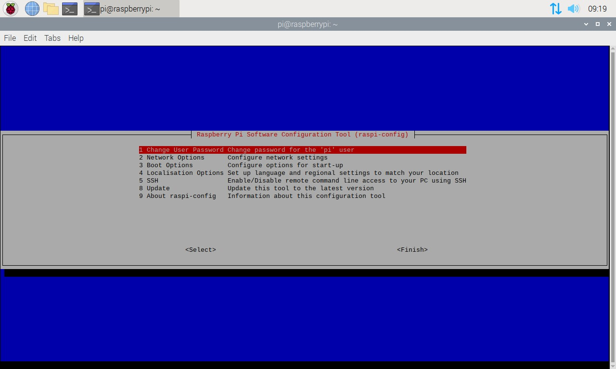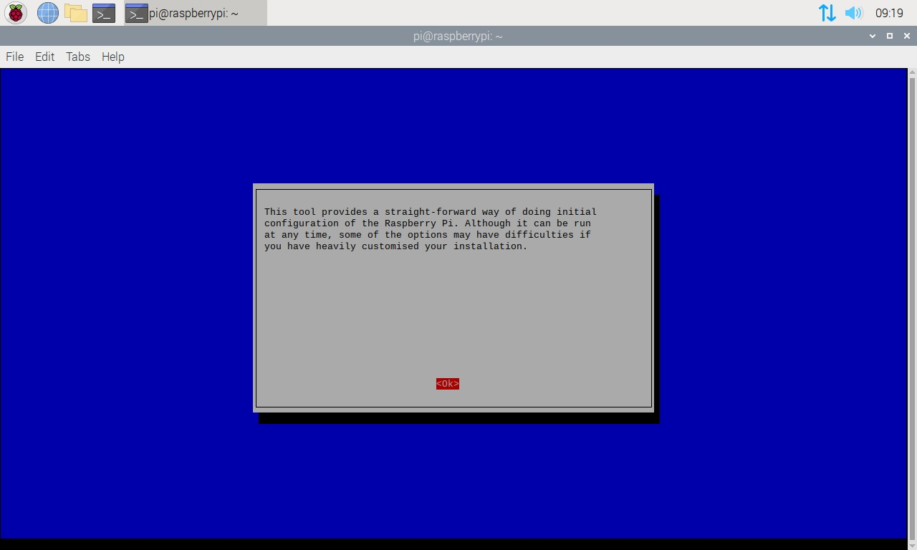

5 Show disk usage

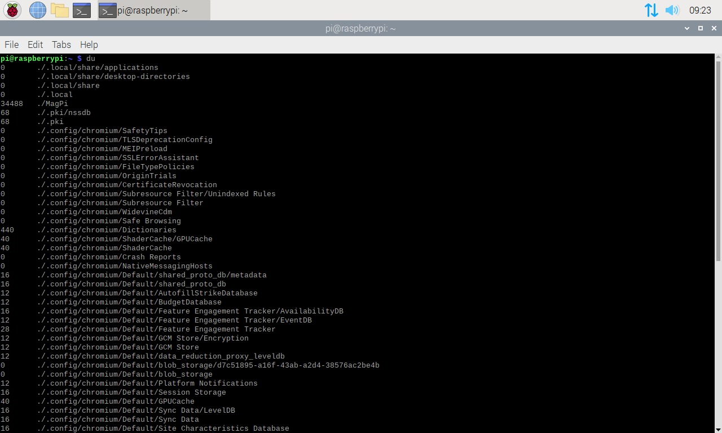

6 Show disk free (Amount of available space in disk)

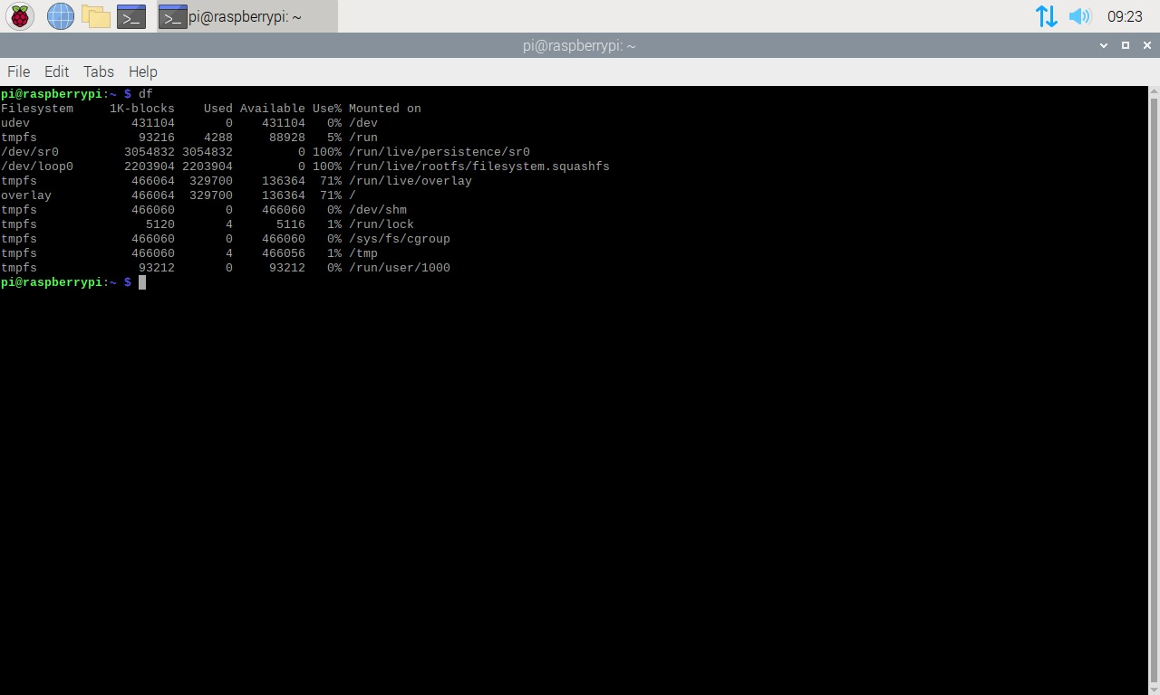

7 Proc file system (procfs) is virtual file system. It contains the useful information about the processes that are currently running

8 cd to change directory

9 ls to list items

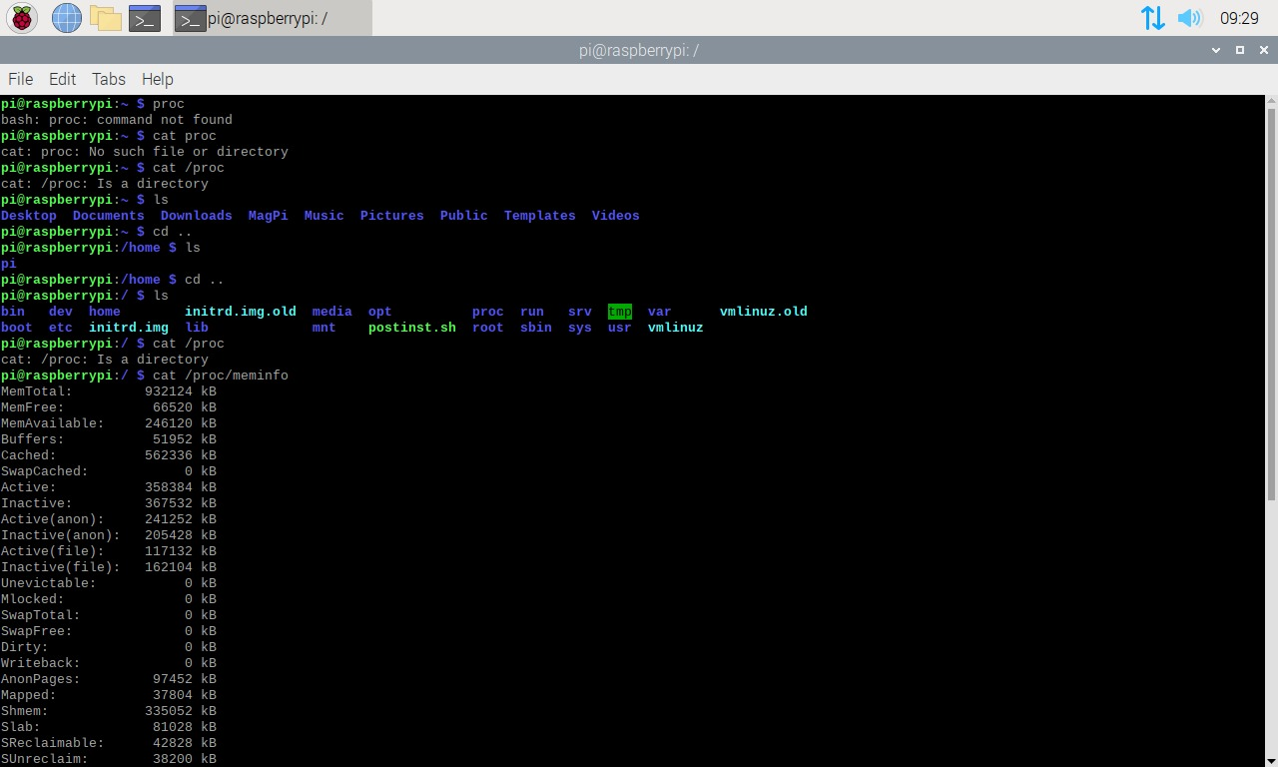

10 Display info about the cpu architecture

11 Reboot system

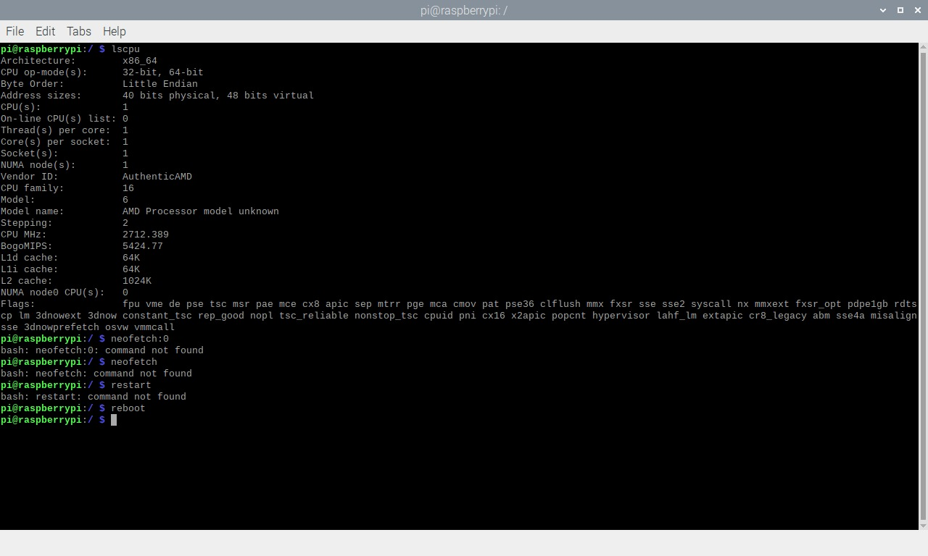

12 Shut down

